**Component Interaction data flow and userstories**

|  |  |
| --- | --- |
| Date | 30 June 2025 |
| Team ID | LTVIP2025TMID29114 |
| Project Name | Sustainable Smartcity Assistant Using IBM Granite LLM |
| Maximum Marks |  |

* **User Input**: Users interact through Streamlit dashboard

1. **API Gateway**: FastAPI routes requests to appropriate services
2. **AI Processing**: IBM HuggingFace processes natural language queries
3. **Vector Search**: Pinecone handles semantic document retrieval
4. **Data Analysis**: ML models process KPI data for insights
5. **Response**: Results rendered in user-friendly interface

* **User Interaction Layer**

**Tool:** Streamlit Dashboard

**Purpose:** Acts as the front-end interface where users interact with the assistant.

**Function:** Users input queries, upload data files (e.g., CSV, PDF), and view results like KPIs, forecasts, anomalies, and AI-generated reports.

**API Gateway Layer**

Tool: FastAPI

Purpose: Manages backend routing of all requests from frontend.

Function:

* Receives user input from Streamlit**.**
* **Directs it to relevant backend services like AI assistant, forecaster, anomaly detector, or document search.**

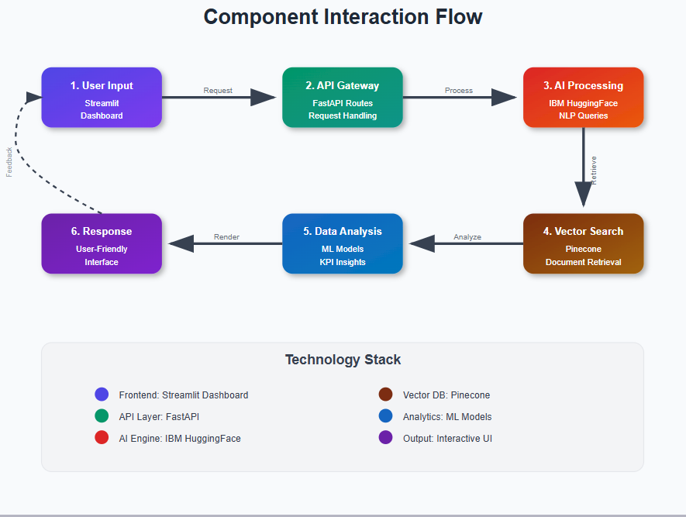

**AI Model Layer**

* **Tool:** IBM Watsonx Granite LLM (ibm/granite-3-8b-instruct via HuggingFace
* **Purpose:** Processes natural language input from users.
* **Function:**
  + Handles chat interactions.
  + Generates smart reports and explanations based on uploaded documents.

**Vector Search Layer**

* **Tool:** Pinecone + MiniLM Embeddings
* **Purpose:** Retrieves semantically relevant information from stored documents.
* **Function:**
  + Converts uploaded documents into vector embeddings.
  + Performs similarity search to retrieve relevant context for AI model.

**Data Analysis & Prediction Layer**

* **Tool:** Custom ML models (NumPy, Pandas, Scikit-learn)
* **Purpose:** Performs KPI forecasting and anomaly detection.
* **Function:**
  + Forecasts water/energy consumption using Linear Regression.
  + Detects abnormal spikes in utility data.

**Response Rendering Layer**

* **Tool:** Streamlit + PDF Generator (fpdf) I use
* **Purpose:** Displays output in user-friendly format.
* **Function:**
  + Renders interactive visualizations.
  + Generates downloadable PDF reports.
  + Logs user feedback and eco tips.